# Homework: jQuery Plugins

This document defines the homework assignments from the ["JavaScript Applications" Course @ Software University](https://softuni.bg/trainings/coursesinstances/details/11). Please submit as homework a single zip / rar / 7z archive holding the solutions (source code) of all below described problems.

## Create a jQuery plugin for creating dropdown list

By given the following:

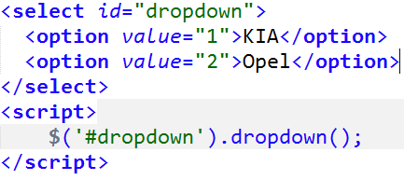

Produces the following HTML and make it work as SELECT node. Selecting one of the generated list item nodes, selects the corresponding option node:

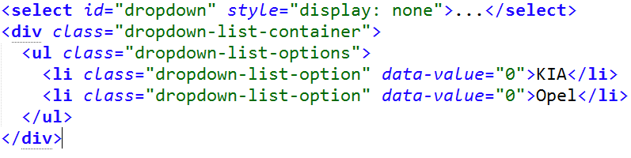

## Create a jQuery plugin for fading in/fading out message box

* Creates a message box
* Show success/error message in the box
  + Showing is done by setting the opacity of the message from 0 to 1 in an interval of 1 second
  + The message disappears after 3 seconds

